Ensure you have the necessary libraries installed (**scikit-learn**, **nltk**, **gensim**). You can install them using pip:

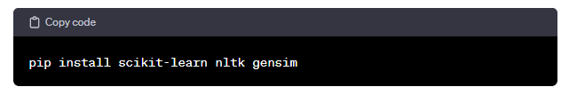This program should perform bag-of-words approach (count occurrence, normalized count occurrence), TF-IDF, and create word embedding using Word2Vec for the given sample data.